Day 13

**Day 13**

1. Display the customer numbers and customer names from customers table who have not placed any orders using subquery

Table: Customers, Orders

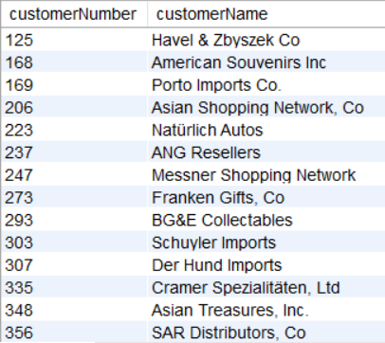

Ans)

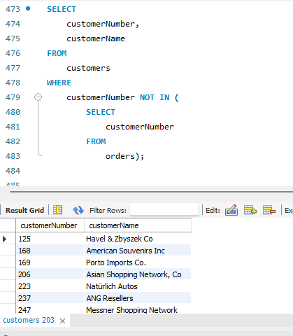

1. Write a full outer join between customers and orders using union and get the customer number, customer name, count of orders for every customer.

Table: Customers, Orders

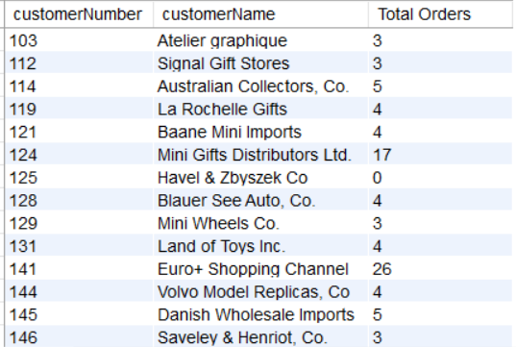

Ans) 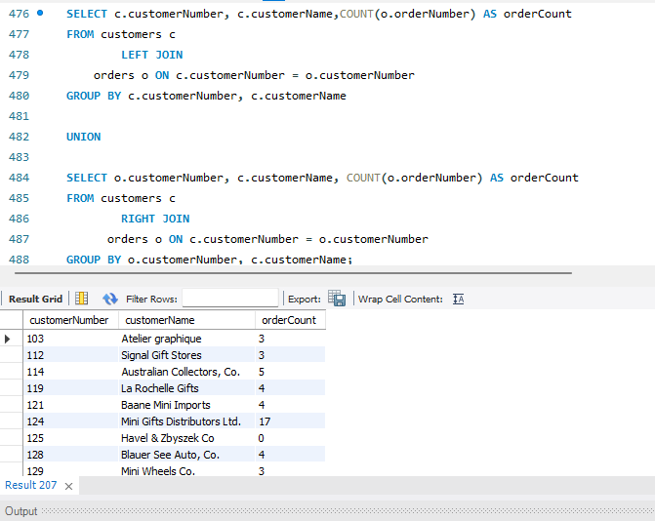

1. Show the second highest quantity ordered value for each order number.

Table: Orderdetails

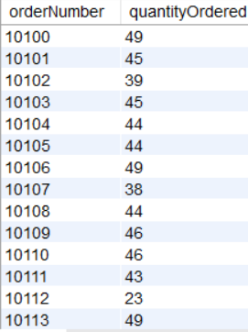

Ans)

Ans) 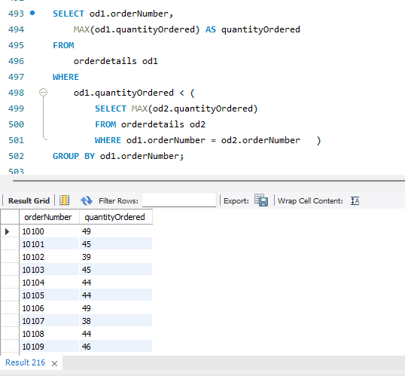

1. For each order number count the number of products and then find the min and max of the values among count of orders.

Table: Orderdetails



Ans) Question asked to count Number of Products – I have added this column too

Above picture is misleading so, I have calculated Max and Min found for each order number

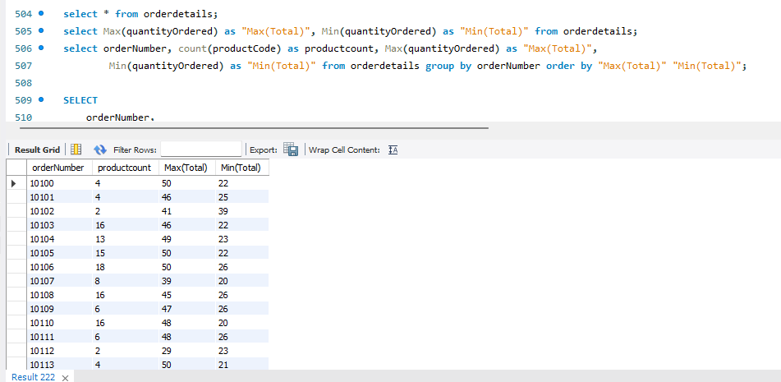

1. Find out how many product lines are there for which the buy price value is greater than the average of buy price value. Show the output as product line and its count.

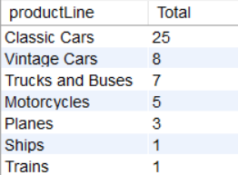

Ans)

